AI-Tool Usage Declaration
TECH PULSE FY-26 | AI/ML Capstone Project - Case Study CS1: AI-Powered AUTOSAR HLD Document Analysis Assistant
Student Name | Diksha Vilas Rokade
PRN | 123B1B249
Institute | Pimpri Chinchwad College of Engineering (PCCOE), Pune
Programme / Batch | B.Tech Computer Engineering, 2023-2027

AI tools / models used for coding and documentation assistance (carried forward from the approved synopsis, Section 7):
AI Tool / Model | Purpose | Artifact Affected
Claude (Anthropic), claude.ai chat assistant | Code scaffolding and debugging; synthetic dataset generator; test and evaluation scripts; drafting of synopsis, report, README and video script. Code and results were reviewed and executed by the student. | Code/ (src, scripts, tests, evaluation, app); Input_Data/ (generator and ground-truth files); Documentation/; Synopsis/; Video/ script
Runtime models (not coding assistants): BAAI/bge-small-en-v1.5 embeddings and Qwen2.5-7B-Instruct via Ollama, both run locally; see Model_Prompts_Config/MODEL_CARD.md.
I have read, run and understood the generated artifacts and am responsible for explaining them during the final evaluation.
Name and Signature: Diksha Vilas Rokade 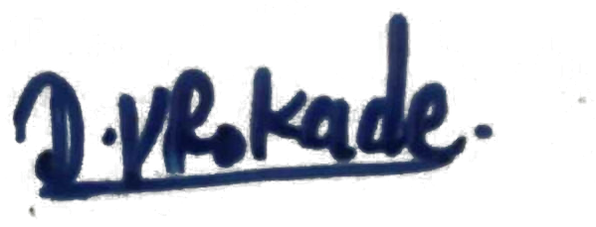 Date: 7-10-2026

